

**Best Address Audit and Validation**

QlikView Detailed Design Document

**<Version No. 1.0>**

Detailed Design Description

Signatures below indicate agreement and/or approval of the contents of this detailed design description. The author and approver names and functions are to be identified in the change documentation (e.g., change number) or project plan.

|  |  |  |
| --- | --- | --- |
| Document Prepared By: | | |
| Name and Function | Signature | Date |
| Indhumathi Sanmugam, Developer- Cognizant technology Solutions | SI | 09/11/2013 |
|  |  |  |

|  |  |  |
| --- | --- | --- |
| Document Reviewed By: | | |
| Name and Function | Signature | Date |
| Tushar Firke | TF |  |
|  |  |  |
|  |  |  |

| Document Approvals : | | |
| --- | --- | --- |
| Name and Function | Signature | Date |
|  |  |  |
|  |  |  |
|  |  |  |

|  |  |  |  |
| --- | --- | --- | --- |
| Revision History: | | | |
| Document Version Number | Document Revision Date | Written By | Change Summary  (Reference section[s] changed) |
| 1.0 | 09/11/2013 | Indhumathi Sanmugam | Document Created |
|  |  |  |  |
|  |  |  |  |
|  |  |  |  |
|  |  |  |  |
|  |  |  |  |
|  |  |  |  |
|  |  |  |  |
|  |  |  |  |
|  |  |  |  |
|  |  |  |  |

Contents

1.0 Introduction 5

1.1. Purpose 5

1.2. Scope 5

1.3. System Design Constraints 5

1.4. Acronyms and Definitions 6

1.5. References 6

2.0 System Design 7

2.1 Background 7

2.2 High Level System Architecture 7

3.0 Data Structure 10

3.1 Fact Table 11

3.2 Server Details 11

3.3 Database Source 12

3.4 Qlikview Vs. database field Mapping 12

4.0 User Interface 13

4.1 Introduction 13

4.2 How to 14

4.3 BAP Audit – Business Rules 15

4.4 BAP Audit – Input Sources 16

4.5 BAP Audit – Outputs 17

4.6 BAP Audit – Counts (Table V/S File) 18

4.7 BAP Audit – Validations (Table V/S File) 19

4.5 Variables Used 19

4.6 Actions and Triggers 20

5.0 Folder Structure 21

6.1 QVD and QVW Reload 22

6.2 Application Refresh 22

7.0 Security Model 22

# Introduction

## Purpose

The document covers the implementation of all the QlikView components, the underlying extraction scripts and implementation of BAP Audit reports.

The intended audience of this document is the application development team, client IT team, application and database administration team. This document provides the detailed guidelines for implementing all the identified modules.

This document is organized into various sections describing the system flow, system modules and detailed design of all the system modules.

## Scope

This design document covers the design aspect of the BAP Audit reports pertaining to:

* QlikView front end to be created to represent the BAP Audit application.
* QlikView QVD file structure to contain the data required to populate the front end
* Workflow for creation of QVD documents as part of the semi-automated process

## System Design Constraints

1. The browser recommended for this application is safari with cookies enabled. The application will be tested on safari browser.
2. The application will be available only within the Abbvie Intranet through VPN Client.
3. Authentication will be Single Sign-on / Auto login.
4. The QlikView documents developed use a single language (English US).
5. The QlikView documents developed use a single time zone (US Central Time).
6. The User interface is implemented based on the guidelines specified in http://www.abbvie.com/
7. The QlikView Server Build, QlikView Publisher and QlikView Client are Version 11 of QlikView.

## Acronyms and Definitions

|  |  |
| --- | --- |
| Acronym | Definition |
| BI | Generic term for Business Intelligence and should refer to QlikView 11 software program |
| QVW | QlikView Application Files |
| QVD | QlikView Data file type |
| QMC | QlikView Management Console |
| BAP | Best Address Processing |

## References

| Document Number | Document Title |
| --- | --- |
| <Need to update> | Functional Requirements Specification |
|  |  |
|  |  |
|  |  |

# System Design

## Background

Best Address Audit and Validation reports used to validate/ check the accuracy of the BAP records. Quarterly reports are generated to track the correctness.

## High Level System Architecture

The following diagram illustrates the high level system architecture of the Application.

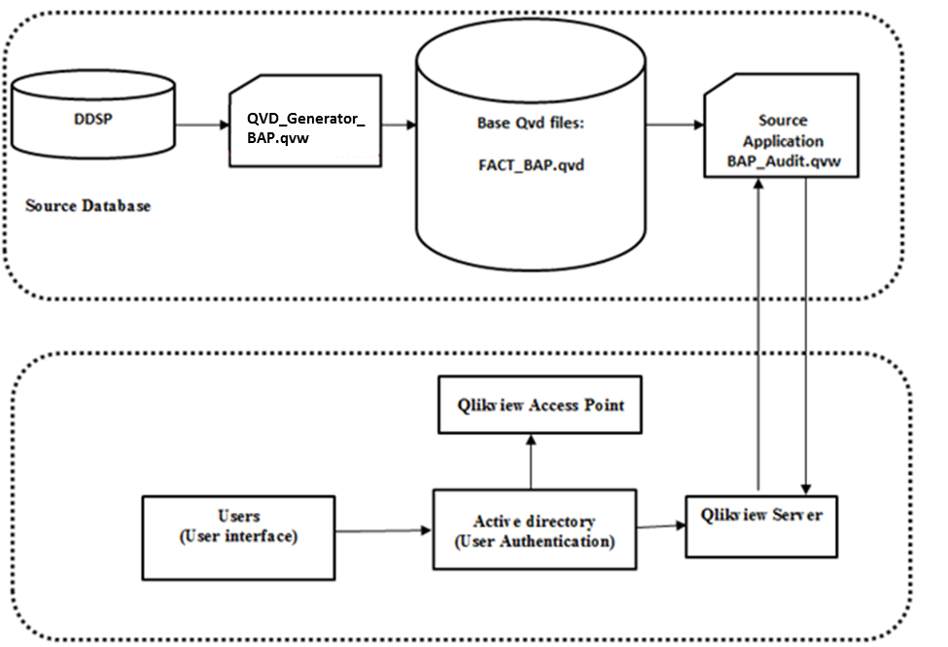

**Source Database:**

Following tables are used to build the application.

**Database**: DDSP

**Tables**:

* PHYN_BEST_ADDRESS_FORENSIC
* CALL_ACTIVITY
* CARMA_CAM_APPRVD_PHYSICIANS
* CAM_VERIFIED_PHYN_ADDRESS
* CUSTOMER_ADDRESS
* PHYN_BEST_ADDRESS
* GEOGRAPHY

**QVD generator:**

QVD_Generator_BAP.qvw

* PHYN_BEST_ADDRESS_FORENSIC is used to get the Count of Unique Physician in HAUF.
* PHYN_BEST_ADDRESS_FORENSIC and CALL_ACTIVITY tables are joined (join key - abbott_customer_id) to get the Count of Call Activity.
* PHYN_BEST_ADDRESS_FORENSIC and CARMA_CAM_APPRVD_PHYSICIANS tables are joined (join key - abbott_customer_id) to get the Count of CAM\CARMA.
* PHYN_BEST_ADDRESS_FORENSIC and CAM_VERIFIED_PHYN_ADDRESS tables are joined (join key - abbott_customer_id) to get the Count of CAM\NON CARMA.
* PHYN_BEST_ADDRESS_FORENSIC and CUSTOMER_ADDRESS tables are joined (join key - abbott_customer_id) to get the Count of IMS.
* PHYN_BEST_ADDRESS_forensic table is used to get the count for each data source.
* DDSP.PHYN_BEST_ADDRESS table is used to get the metrics used in the Audit output validation in database-check.
* DDSP.PHYN_BEST_ADDRESS_ETL table is used to get the metrics used in the Audit output validation in file-check.
* DDSP.PHYN_BEST_ADDRESS, GEOGRAPHY, PHYN_BEST_ADDRESS_FORENSIC tables are used to get the metrics used in the Audit validation in database.
* DDSP.PHYN_BEST_ADDRESS, GEOGRAPHY, PHYN_BEST_ADDRESS_FORENSIC tables are used to get the metrics used in the Audit validation in file.
* RULE_PACKAGE_RULE, RULE_PACKAGE_VERSION_RULE, SALES_FORCE_PACKAGE_RULE, SALES_FORCE_PRODUCT_XREF are used to get the sales period, sales group name and rule package version id.
* All the metrics are concatenated and the fact table created.

<<<For more details refer mapping document section – 3.5 >>>

**Source Application:**

BAP_Audit.qvw

* FACT_BAP.qvd is loaded into BAP_Audit.qvw, Fact_BAP has been created.
* User interface has been created with the Qlikview chart object.

***SQL Database:*** Details of the Franchise, Abbott_Customer_Id and the sales Quarter has been loaded from Teradata databases DDSP.

***QVD files***: The QVD files are data extracts from the flat files for the QlikView application.

***QVW files***: The QVW files define the transformation and front end for a QlikView application

**QlikView Publisher (QVP):** QlikView Publisher will be used to reload the QVD and the QVW files when new data needs to be refreshed and distribute to the QlikView Server.

***QlikView Server (QVS)***: The QlikView documents will be deployed in the QlikView Server. QlikView Server handles the communication between clients and the QlikView applications.

|  |  |
| --- | --- |
| **Tab Name** | **Description** |
| Introduction | This tab provides the General information about BAP Audit application. |
| BAP Audit – Business Rules | This report Contains the Business rules |
| BAP Audit – Input Sources | This report will display the data for last four Quarter (depends on the user selection) against the input data sources. |
| BAP Audit - Outputs | This report will display the data for last two Quarter (depends on the user selection) against the metrics defined for the output data sources. |
| BAP Audit – Validations (Table V/S File) | This report used to validate the record against the File that are generated by ETL team |
| BAP Audit – Exception | This report displays the Invalid Address. |

# 3.0 Data Structure

The following diagram indicates the data structure used for the BAP Audit reports.

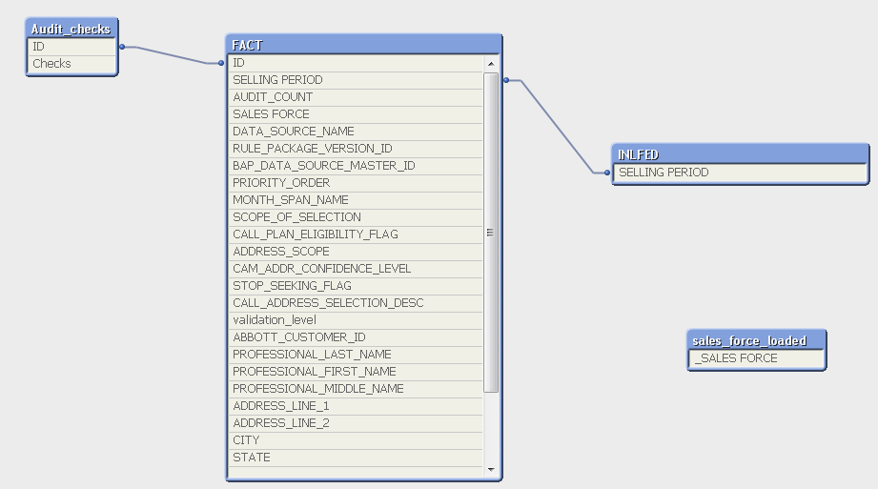

## 3.1 Fact Table

FACT_BAP

* AUDIT_COUNT
* SELLING PERIOD
* SALES FORCE
* ID
* DATA_SOURCE_NAME
* RULE_PACKAGE_VERSION_ID
* BAP_DATA_SOURCE_MASTER_ID
* PRIORITY_ORDER
* MONTH_SPAN_NAME
* SCOPE_OF_SELECTION
* CALL_PLAN_ELIGIBILITY_FLAG
* ADDRESS_SCOPE
* CAM_ADDR_CONFIDENCE_LEVEL
* STOP_SEEKING_FLAG
* CALL_ADDRESS_SELECTION_DESC
* validation_level
* ABBOTT_CUSTOMER_ID
* PROFESSIONAL_LAST_NAME
* PROFESSIONAL_FIRST_NAME
* PROFESSIONAL_MIDDLE_NAME
* ADDRESS_LINE_1
* ADDRESS_LINE_2
* CITY
* STATE
* ZIP_CODE
* AMA_PDRP_FLAG
* ABBOTT_BEST_SPECIALTY_CODE
* _QNO
* _YNO

## 3.2 Dimension Table

This table contains the Audits check used in the report with the ID.

**Audit_Checks**

* ID
* Checks

Sales_force_loaded:

Isolated table to show the sales loaded in the dashboard.

## 3.2 Server Details

The following are the details of the server which we are used for this application.

**Server Name**: ppdwp1 (Production)

**Databases**: DDSP

## 3.3 Database Source

Following table provides the description of each table used in the BAP Audit reports:

|  |  |  |
| --- | --- | --- |
| **Database Name** | **Table Name** | **Description** |
| DDSP | PHYN_BEST_ADDRESS_FORENSIC | This table contains the information about the Physician Address. |
| CALL_ACTIVITY | This table contains the information about Call Activity. |
| CARMA_CAM_APPRVD_PHYSICIANS | This table contains the information about CARMA_CAM Physician Address. |
| CAM_VERIFIED_PHYN_ADDRESS | This table contains the information about CAM_VERIFIED physician address. |
| CUSTOMER_ADDRESS | This table contains the information about the Customer address. |
| PHYN_BEST_ADDRESS | This table contains the information about Physician best address. |
| GEOGRAPHY | This table contains the geographical information. |

## 3.4 Qlikview Vs. database field Mapping

This section shows the mapping between DDSP tables against the Qlikview fields,

# 4.0 User Interface

This section contains indicative screen designs for the QlikView front end.

* Introduction
* How to
* BAP Audit – Business Rules
* BAP Audit – Input Sources
* BAP Audit - Outputs
* BAP Audit – Validations (Table V/S File)
* BAP Audit – Exception

## 4.1 Introduction

This tab provides the General information about the BAP Audit reports.

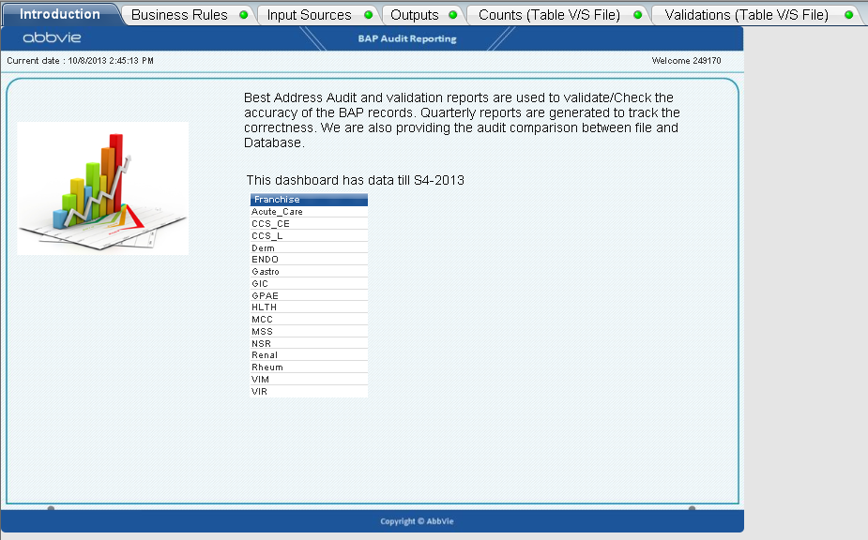

## 4.2 BAP Audit – Business Rules

This report contains the BAP Business rules for the given selling period and the franchise. The user is allowed to filter by selling period and sales name.

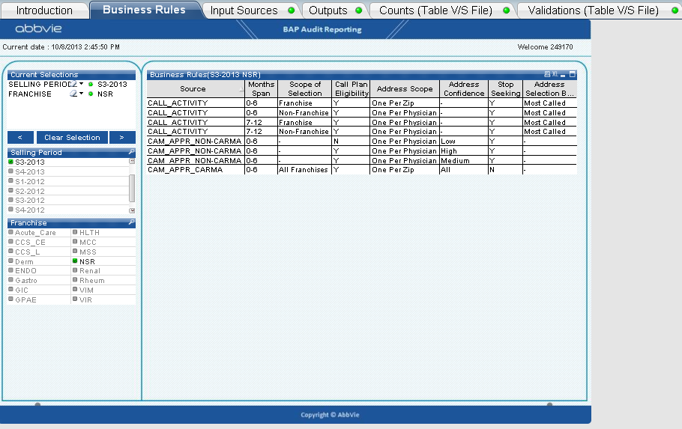

## 4.3 BAP Audit – Input Sources

This report will display the count of the input data sources for last four Quarter (depends on the user selection). The user is allowed to filter the data by sales and sales period.

**Table View**

This report will display the count of the input data sources for last four Quarters. The red color drop down indicator will tells the user that the count of current quarter is less than 10% of previous quarter. Upward arrow will tells the user that the current quarter data is more than 10% of previous quarter. If the count is less than the previous sales then the arrow will indicate to the user that the sales value is less/high. The user is allowed to set the threshold value in the in input box there in the report.

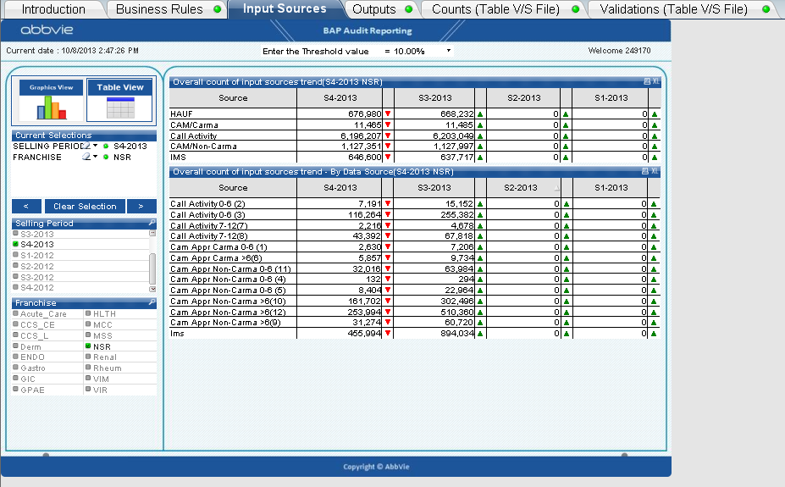

**Graphics View:**

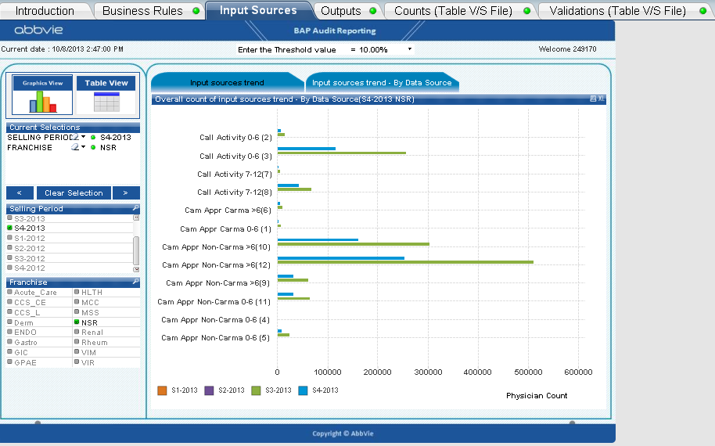

## 4.5 BAP Audit – Outputs

This report will display the data for the defined metrics for last two Quarters (depends on the user selection). The user is allowed to filter the data by sales and sales period.

**Table view:**

This report will display the data for the defined metrics for last two Quarters (depends on the user selection). The red color drop down indicator will tells the user that the count of current quarter is less than 10% of previous quarter. Upward arrow will tells the user that the current quarter data is more than 10% of previous quarter. . If the count is less than the previous sales then the arrow will indicate to the user that the sales value is less/high. The user is allowed to set the threshold value in the in input box there in the report.

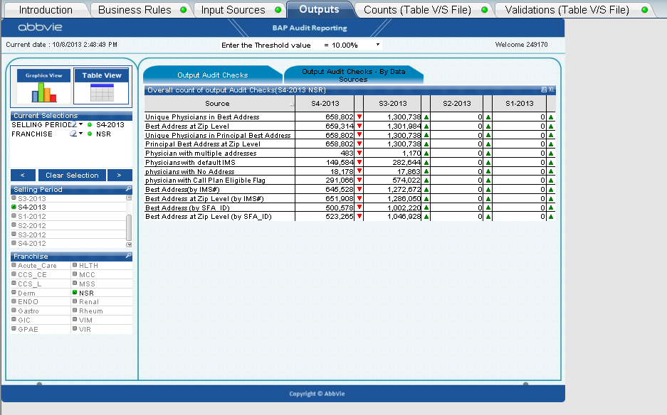

**Graphics view:**

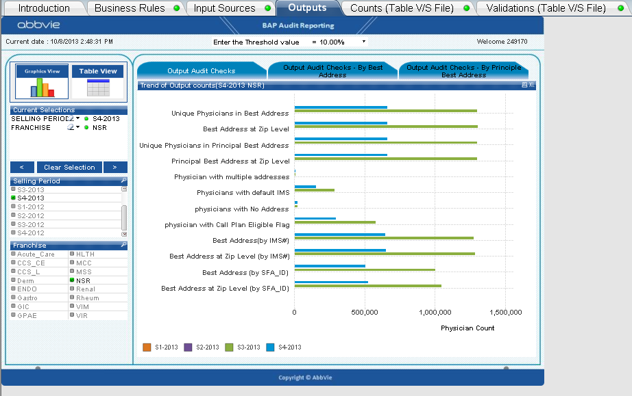

4.6 BAP Audit – Counts (Table V/S File)

This report used to validate the database count of the BAP audit metrics against the file. The BAP extracted file will be loaded into DDSP database by the ETL process. If the count of DB value is deviated from the file count then the value will be highlighted in the red.

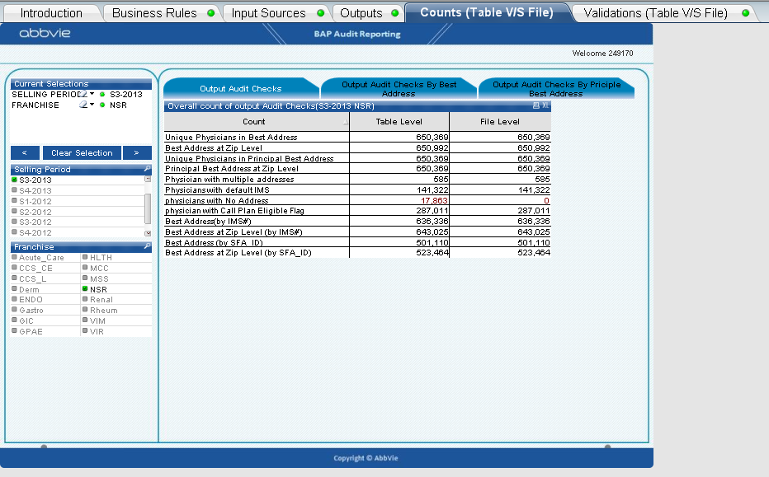

## 4.7 BAP Audit – Validations (Table V/S File)

This report used to validate the database record against the file. The BAP extracted file will be loaded into DDSP database by the ETL process. If the count of DB value is deviated from the file count then the value will be highlighted in the red.

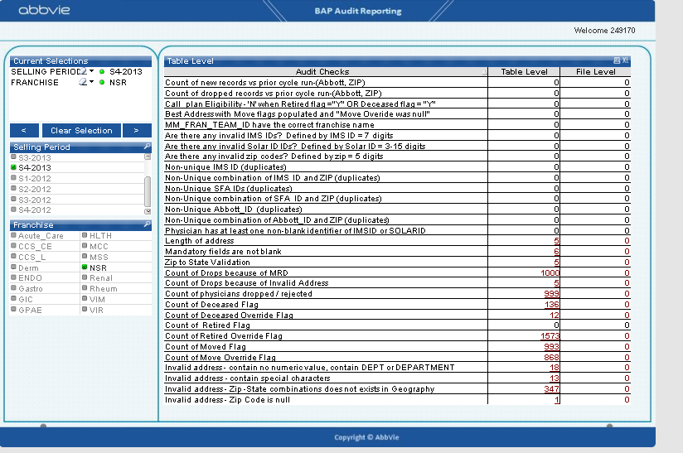

On clicking the count of the audit checks, will navigate the user to the detailed record. It should display the table in the below format. Click on the “BACK” button to view go back to the front page.

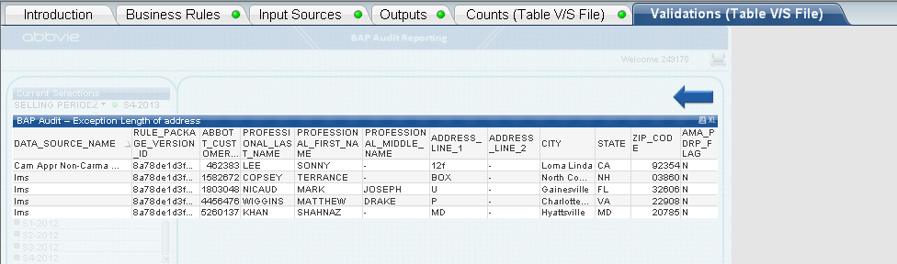

## 4.5 Variables Used

The following are the variables which are used in the application.

* vQuater is used to display the data for the current Quarter
* vQuater_1 is used to display the data for the current Quarter-1
* vQuater_2 is used to display the data for the current Quarter-2
* vQuater_3 is used to display the data for the current Quarter-3
* vShowTableInput is used to show/hide table view in the input audit check report.
* vShowGraphicsInput is used to show/hide Graphics view in the input audit check report.
* vShowTableOutput is used to show/hide table view in the output audit check report.
* vShowGraphicsOutput is used to show/hide graphics view in the output audit check report.
* vShowDBFileCheck is used to show/hide table for the file vs. DB comparisons
* vColorQ1 is used to set the color for the Quarter 1 in the bar chart.
* vColorQ2 is used to set the color for the Quarter 2 in the bar chart.
* vColorQ3 is used to set the color for the Quarter 3 in the bar chart.
* vColorQ4 is used to set the color for the Quarter 4 in the bar chart.

## 4.6 Actions and Triggers

The following are the actions which we are used in our application.

* Clear Selections-Action is set to clear all the fields which are selected.
* Forward-Action is set to show the previous selection
* Backward-Action is set to show the backward selection. All the clear options are at Sheet level.
* Print-Action is set to print the particular sheet. It’s at Sheet level.
* BACK is used to navigate the user from the detailed table to home page.
* Table view will display the data in table format
* Graphic view will display the data in graphics view.

# 5.0 Folder Structure

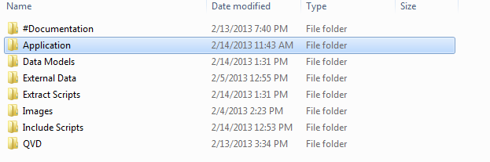

**Folder structure for BAP Audit reports**

* #Documentation –
  + Documentation specific to HLink Analytics App
  + System Administration (files created by QlikView Server and Publisher for system logging, performance monitoring, etc.)

▪ Log Files

* Application

QlikView Documents – the QVW and related files that make up the QlikView application.  These are the End User Documents (the reloaded source documents published for users to consume).

* Data Models

Data model information for the application, used to integrate QVD and other data to create the data model.

* External Data

Other Data (not QVD files) - Spreadsheets, other data source files - xls, csv, or any other type of data.

* Extract Scripts

Base QVW: Raw data extracted from the data source is loaded into Qlikview and store it into a QVD.

* Images

Images used for the QlikView application (Country flags, Abbvie logos, etc.)

* Include Scripts

Include Scripts folder contains Connection String Details which will be used in the application for different environments.

* QVD

QVD folder contains Base QVD which stores the QVD’s which are created by the respective QVW’S.

## 6.1 QVD and QVW Reload

Qvd is refresh is done in two ways,

1. Full load – will load the entire data to qvd
2. Incremental load – loading old data from the QVD and new records from the database and combine into single QVD.

We will be creating two different applications. One is for full load another one is for incremental load. The incremental load is done by Quarterly basic.

Qvd loads,

1. First time load will be full load
2. Next time we will be loading the data by incremental logic
3. Takes the max sales period from the previous Quarter QVD (for example – S4-2013)
4. takes the old data from old qvd and loads the new record into single qvd (if we run the application by S1-2014 the new qvd will have data till S4-2013 + S1-2014 data)

## 6.2 Application Refresh

Occurs when the Data model task ran successfully

1. The Application refreshes the data from the QVD.
2. The application is distributed to the respective users.

# 7.0 Security Model

Security model is a scheme for specifying and enforcing security policies. A security model may be founded upon a formal model of access rights.

User authentication takes place from the active directory group comprising of all the end users.

There is no data level security being enforced upon currently. All authenticated users are allowed to view the dashboard with the entire data loaded and no data reductions.

During the deployment User group will be created with 20 users. Only those 20 users can access the reports others cannot access the report.